Section A
- What is the definition of a polymer?
Tick ( ) one box.
- Repeating units that join together to make a long chain | 
- Small molecules held together by intermolecular forces
- A long molecule made up of many repeating units

- Give the name for repeating units that polymers are made from.

_____________________________________________________________________________________

- What polymer would be made from repeating units of ethene?
Tick ( ) one box.
- poly(propene)
- poly(ethene)
- poly(ethane)

- Look at the diagram representing a polymer below.
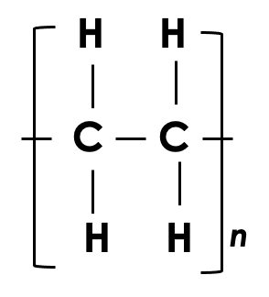

- What does the single straight line in between the H and C represent?
_______________________________________________________________________________________________
- What does the ‘n’ represent?
_______________________________________________________________________________________________
Section B
- What type of bonds are there in a polymer chain?

_______________________________________________________________________________________________
- Describe the forces that occur between polymer chains.
____________________________________________________________________________________________________________________________________________________________________________________________________________________________________________________________________________________________________________________________________________________________________________________________
- What type of polymers melt when heated?
_____________________________________________________________________________________
- Draw the molecular formula for a polymer molecule with 50 carbon atoms.

- Explain why thermosetting polymers are suitable as a material for a saucepan handle.
____________________________________________________________________________________________________________________________________________________________________________________________________________________________________________________________________________________________________________________________________________________________________________________________

- Thermosoftening polymers are used to make plastic bottles and food packing. Explain why thermosoftening polymers would not be suitable for storing hot food.
____________________________________________________________________________________________________________________________________________________________________________________________________________________________________________________________________________________________________________________________________________________________________________________________

- The diagrams below show models for the structures of a thermosetting polymer and a thermosoftening polymer.
Identify which is which and explain why.

A B
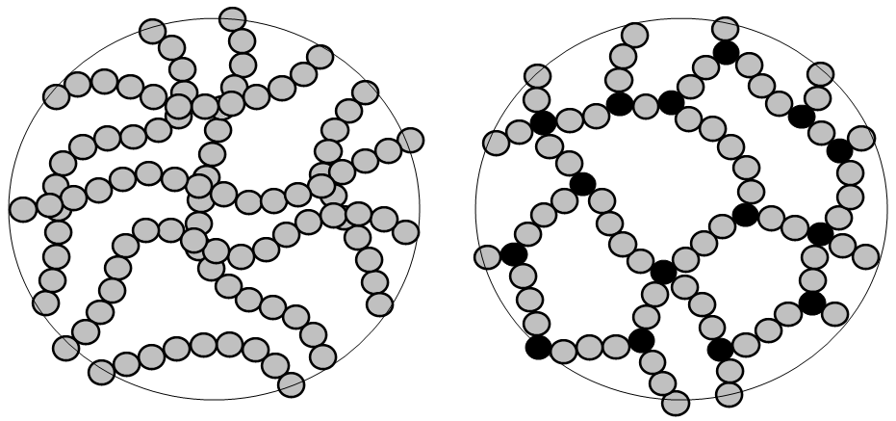
Image from Wikimedia

____________________________________________________________________________________________________________________________________________________________________________________________________________________________________________________________________________________________________________________________________________________________________________________________

Section C

- Carbon dioxide and diamond both contain carbon.

- Describe the bonding in carbon dioxide.
- Describe the bonding in diamond.
- Explain why carbon dioxide is a gas at room temperature but diamond is a solid

